Peter Julius M. Estacio
Grouped with:
Niño Aloysius V. De Mesa
Christian James S. Madariaga
ENGG 151.01-A
March 4, 2026

Progress Report 2 for Project 2: Fourier Transform

As of March 4, 2026, no additional progress has been made since the first progress report. As such, further work still includes accepting arguments when run from the command line, file output according to specifications, and implementing output to console for only calculations with 10 steps or less. The screenshot of the results shown are below.
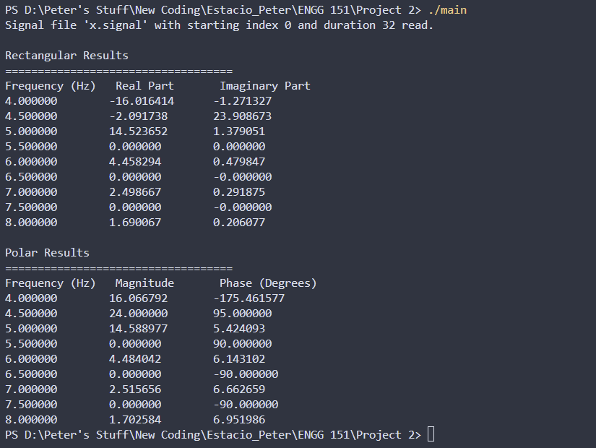
sample screenshot – executable main.exe run and resulting output to console

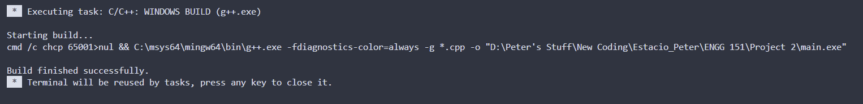
sample screenshot – compilation on Visual Studio Code

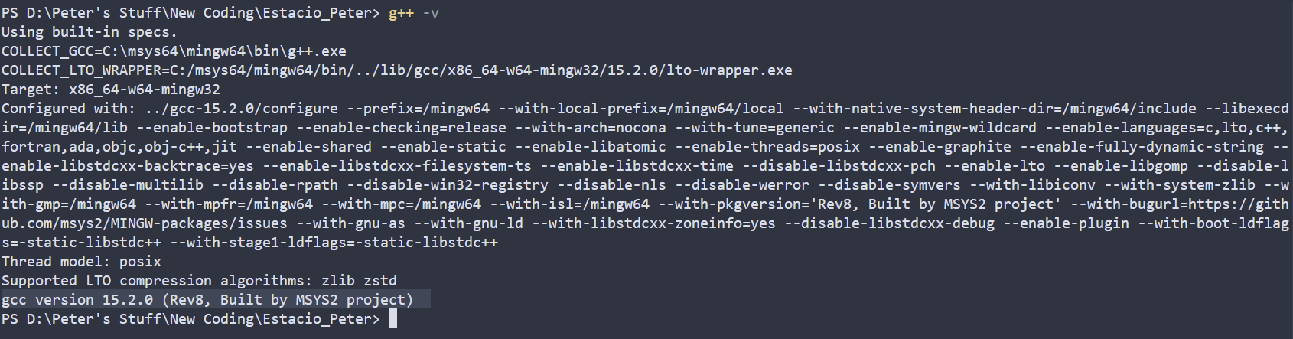
compiler version – gcc version 15.2.0 (Rev8, Built by MSYS2 project)

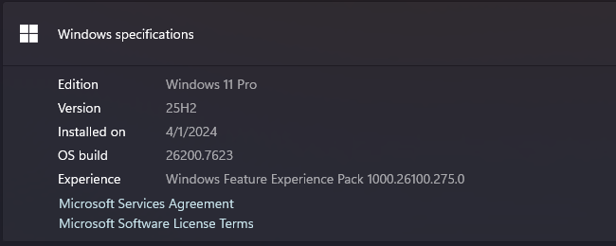
operating system - Windows 11 Pro, 25H2, build 26200.7623
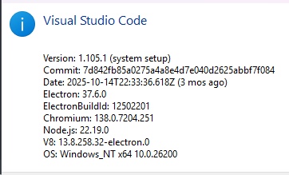
IDE – Visual Studio Code ver 1.105.1

